To What Extent is Time Dilation a Critical Factor in the Design and Operation of Modern Aerospace Systems?
By Aman Chohan

Contents
Introduction 3
Methodology 4
Theoretical Foundations 5
2.1 Newtonian View of Time vs Aerospace Engineering 5
2.2 Classical View of Velocity 5
2.3 Inertial Frames 6
2.4 Introduction to Relativity 6
2.5 Spacetime continuum 6
Special Relativity (1905) 8
3.1 Relativity of Simultaneity 8
3.2 The Speed of Light and Time Dilation 8
3.3 Lorentz Transformations 9
3.4 Chapter Summary 11
General Relativity (1915) 12
4.1 Curved Spacetime 12
4.2 The Equivalence Principle 12
4.3 Time Dilation Near Massive Bodies 13
4.4 Chapter Summary 13
Challenges in Aerospace Systems 15
5.1 Introduction 15
5.2 Time Dilation in GPS Satellites 15
5.3 Time dilation in orbital mechanics 19
5.4 Time Dilation Effects on Rockets Leaving Planetary Gravity 25
5.5 Limitations of Methods 27
5.6 Chapter Summary 28
Mitigation Strategies for Time Dilation 29
6.1 Introduction 29
6.2 The Atomic Clock 29
6.3 Engineering Corrections Applied to Satellite Clocks 30
6.4 Deep Space Atomic Clock (DSAC) 31
6.5 Chapter Summary 31
Conclusion 32
Mathematical Derivations 34
7.1 The Lorentz factor 34
7.2 Time Dilation due to Special Relativity 36
References 39
Bibliography 41

Introduction
Time dilation: the counterintuitive phenomenon in which time does not pass uniformly but changes according to an observer’s motion and gravitational environment. First predicted by Einstein, it has become central to modern theoretical physics and continues to influence how we understand space, time, and high-speed systems. Its presence in popular culture, most notably in Interstellar, has helped illustrate these ideas to wider audiences, but its scientific relevance extends far beyond fiction.
In this dissertation, I will examine time dilation not simply as a theoretical prediction that challenged classical assumptions, but as a real consideration in the design and operation of aerospace systems. Chapter 2 introduces the foundational concepts required to understand relativity, followed by Chapters 3 and 4 where I explain the principles behind velocity-based and gravitational time dilation. Chapters 5 and 6 then analyse the practical consequences of these effects for satellites, rockets, and deep-space missions, including calculations showing the magnitude of relativistic discrepancies in different scenarios. This allows me to evaluate whether these effects create genuine operational challenges in navigation, synchronisation, and mission timing, or whether they remain secondary concerns in most contexts. I then examine how engineers correct for relativistic drift and consider whether these corrections are essential across all aerospace domains or only in specialised cases. Finally, I present the key mathematical derivations and conclude by assessing the extent to which time dilation influences the precision, reliability, and design requirements of modern aerospace engineering. Ultimately, this dissertation will consider how significant time dilation is as a risk factor in high precision aerospace engineering, and the situations in which it becomes most apparent and therefore most important to account for.

Methodology
This investigation required a balance between theoretical physics and practical aerospace engineering, so a structured research approach using a Gantt chart was employed to ensure both accuracy and relevance was achieved. The project began by identifying the core physical principles needed to analyse time dilation in real aerospace systems. Primary theoretical material was drawn from Einstein’s original papers on relativity and from university-level resources such as Physics LibreTexts and the University of Cambridge archives on Newton’s work. These sources were selected because they present the fundamental physics clearly and in the words of the scientists who originally theorised them, ensuring exceptional accuracy. However, I recognized a methodological challenge: these primary texts were conceptually dense and used archaic notation. To ensure my interpretation was correct, I used them for 'theoretical purity' but translated their logic into the modern algebraic formulas found in Physics LibreTexts to ensure the math remained applicable to current aerospace standards.
Engineering applications required the use of specialist aerospace material. Texts on GPS systems, including Kaplan and Hegarty’s “Understanding GPS Principles and Applications”, were selected because they provide detailed numerical values for orbital parameters and clock corrections. Calculations were further verified using sources such as Mishra P’s “Inside the Box: GPS and Relativity”, which aligned closely with the results I had obtained. Additional resources, including NASA technical articles, were consulted to understand engineering practices related to satellite clocks and deep space navigation. In cases where the literature was incomplete or did not explicitly describe relativistic corrections, such as with the Deep Space Atomic Clock, I moved from a passive researcher to an active one, applying engineering judgement to interpret the implications of timing stability based on known stability constants.
Video sources were repeatedly used throughout the research stage primarily to support conceptual understanding and visual intuition. Notably, Khan Academy was consulted to support comprehension of the mathematics behind Lorentz transformations. While these videos were vital for bridging the gap between abstract theory and my own calculations, I maintained a critical stance. I treated video explanations as conceptual 'blueprints' which I always cross-referenced against written scientific literature to ensure that helpful but simplified analogies (like the 'rubber sheet' model) did not compromise the technical accuracy of my dissertation.
Simplifications were introduced only when necessary to keep the mathematics within A-level scope. For example, relativistic effects during a Hohmann transfer were evaluated at periapsis and apoapsis rather than integrating over the full elliptical orbit. I made this deliberate methodological choice to ensure the physics remained transparent; while integration is more precise, the 'snapshot' method more clearly illustrates the relationship between specific altitudes and time dilation for the reader. These choices are discussed transparently in the Limitations of Methods section.
Three aerospace scenarios were selected to provide a representative sample of where time dilation could influence engineering practice: GPS satellites, an orbital manoeuvre, and a rocket reaching escape velocity. These were chosen because they span different gravitational fields, velocity regimes, and operational accuracies, allowing a clear evaluation of where relativistic corrections become essential. Accuracy was prioritised by cross-checking values across sources such as [9] and [10], and by using approximations only when they did not affect the overall conclusions.

Theoretical Foundations

2.1 Newtonian View of Time vs Aerospace Engineering
Before we look at time dilation, it is important to understand the Newtonian view of time. Newton argued that time is absolute and universal regardless of reference frame, relative motion or location. In his own words, it is “absolute, true and mathematical… of itself, and from its own nature, flows equably without regard to anything external” [1]. In simple terms, Newton believed the flow of time cannot be influenced or changed by external factors.
This model forms the basis of classical mechanics and remains highly effective for describing everyday phenomena. Our daily lives take place at low velocities and in similar gravitational fields where relativistic effects are negligible, so we never experience any noticeable distortion in the flow of time.
However, aerospace engineering operates beyond these limits. Spacecraft and satellites reach speeds and gravitational environments where classical mechanics no longer describes reality with sufficient accuracy. Under these extreme conditions, Newton’s assumption of absolute time breaks down, and engineers must use relativistic physics to predict how time behaves. Time dilation is one such relativistic consequence and becomes essential in spaceflight, navigation satellite systems and during orbital manoeuvres.

2.2 Classical View of Velocity
Before discussing Special Relativity, we need to define velocity in classical physics. Velocity is the rate of change of an object’s displacement with respect to time, measured relative to a chosen reference frame. It is a vector quantity, so both magnitude and direction matter. Importantly, velocity depends on the reference frame from which it is measured.
This can be seen through a simple thought experiment. Consider two trains. Train A travels at 10 m/s and Train B travels at 20 m/s, as shown in Figure 1. An observer standing on the platform will record those speeds in each train’s direction of motion.

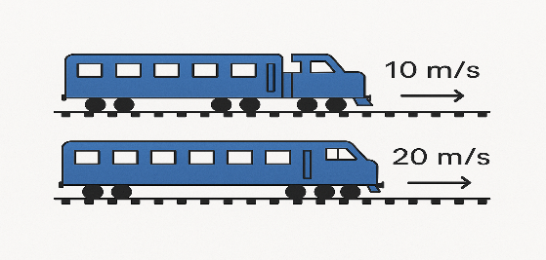
Figure 1 AI-Generated Illustration
However, if the observer stands inside Train A, Train B will appear to pass at 10 m/s because the relative velocity is 20 − 10 m/s. This example is simple, but it forms the first step towards understanding relativity.
In classical mechanics, we assume that speeds add or subtract depending on the motion of the observer. This rule works well for everyday situations because the speeds involved are low. However, at extremely high velocities, this classical rule no longer describes motion accurately. The relationship between different observers becomes more complex and requires the relativistic model instead. This shift in how motion is understood is one of the reasons why time behaves differently in Special Relativity.

2.3 Inertial Frames
To understand both Special Relativity and General Relativity, we must familiarise ourselves with inertial frames. Essentially, an inertial frame is one in which Newton’s first law holds true, so an object with no net external force acting on it will remain at rest or move with constant velocity. A non-inertial frame accelerates or rotates, producing apparent forces inside the frame.
This distinction matters because Special Relativity only applies to inertial frames moving at constant velocities relative to each other. Non-inertial frames require General Relativity, since acceleration and gravity affect the passage of time. For example, a passenger in a car moving at constant velocity is in an inertial frame, while a passenger travelling around a roundabout is in a non-inertial frame because the circular motion creates a resultant force that the passengers feel as a sideways pull.

2.4 Introduction to Relativity
In the early twentieth century, Einstein proposed that quantities like time, length and mass are not absolute but depend on the observer’s frame of reference. This led to two revolutionary theories:
- Special Relativity (1905)
- General Relativity (1915)
Although these theories have broad implications, this dissertation focuses on time dilation. In Special Relativity, time slows down for objects moving at high speeds relative to an observer. In General Relativity, time slows down in stronger gravitational fields. These effects do not exist in isolation. They arise from a deeper shift in how the universe is structured. Einstein argued that space and time cannot be treated as separate entities and that both must be combined into a single geometric framework. This leads directly to the concept of spacetime.

2.5 Spacetime continuum
Spacetime provides the foundation that links Special Relativity and General Relativity and explains why time dilation occurs in both cases. Einstein unified space and time into a four-dimensional entity called spacetime. Spacetime consists of three spatial dimensions and a fourth dimension of time, which together form the spacetime continuum. Because of this framework, Einstein rejected Newton’s belief that time flows independently of everything else. Instead, he argued that time is flexible and depends on the observer’s motion and gravitational environment.
This means that the faster an object moves, or the stronger the gravitational field it is in, the more slowly time passes for that object relative to an outside observer [2]. Although every system experiences this effect to some degree, the velocities and gravitational field we encounter on Earth make time dilation negligible. Aerospace engineers cannot make this approximation because high-speed flight and space missions cause measurable differences in the flow of time.

Special Relativity (1905)

3.1 Relativity of Simultaneity
As established already, time is not a fixed quantity nor is it absolute, rather it depends on judgments of simultaneous events [3] between reference frames. For example, when you say a train arrived at 3:00 PM, you are really referring to the event of the train’s arrival being simultaneous with your watch reading 3:00 PM. This is a judgment made in your own frame of reference. Newton assumed that such judgements were absolute and identical for all observers. However, a simple thought experiment shows that this assumption is incorrect.
Imagine standing at the centre of train A, which is in uniform motion. Two lightning bolts strike the front and rear of the train at the same moment from the perspective of an observer on the platform. Light from each strike travels towards you at the speed of light c. Yet because the train is moving forward, you move towards the point where the front strike occurred and away from the rear-end strike. As a result, you receive the light from the front strike first and conclude that the front strike happened first. Meanwhile, the observer on the platform, who is stationary and equidistant between both strikes, receives both flashes at the same time and concludes that they were simultaneous. This shows that both reference frames disagree with the order of events. This disagreement is not caused by perception or reaction time, but by a fundamental difference in how each observer orders the events. It shows that simultaneity is not absolute but depends on the observer’s frame of reference and this is the key insight into Einstein’s Special Relativity.
The relativity of simultaneity sets the foundation for understanding why time does not flow identically for all observers. Once simultaneity becomes relative, the passage of time can no longer be universal, which leads directly into Special Relativity’s treatment of light and motion.

3.2 The Speed of Light and Time Dilation
Einstein proposed that the speed of light in a vacuum is a universal constant and remains the same for all observers, regardless of their motion [3]. This means that an observer moving at 0.8c in the same direction as a beam of light still measures the photon travelling at c rather than at 0.2c, which classical mechanics would predict. This idea was supported by the Michelson-Morley experiment, which showed that light travels at the same speed in all directions regardless of Earth’s motion [6]. This result contradicts the classical view of velocity addition introduced in Chapter 2 and reveals that light behaves fundamentally differently from everyday objects.
A clear demonstration of how this postulate leads to time dilation is shown in Brian Cox’s thought experiment in “Is Time Travel Possible” [4]. The experiment models a simple clock using a beam of light bouncing between two parallel mirrors. When stationary, the light travels vertically between the mirrors. However, when the clock is set in motion, the light must follow a diagonal path to reach the same points, which increases the distance it travels between each reflection. Since the speed of light cannot change, the increased distance causes an increase in the measured time between ticks. This means that the clock runs more slowly when it is moving. This model captures the essence of velocity-based time dilation and prepares the ground for the mathematical formulation presented later in the dissertation.
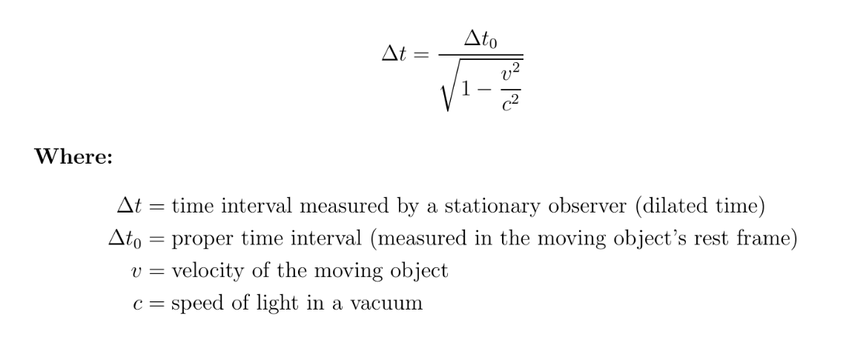
Figure 2 Generated in Latex, Capturing Time Dilation due to SR
The link between the invariance of the speed of light and the slowing of time is central to Special Relativity. To formalise this relationship, we need a mathematical framework that describes how time and space coordinates transform between observers in relative motion. This leads directly to the Lorentz transformations.

3.3 Lorentz Transformations
Lorentz transformations describe how the space and time coordinates of an event change between inertial frames that move at a constant velocity relative to one another. They provide the mathematical structure that connects the relativity of simultaneity with the behaviour of time and space in Special Relativity.

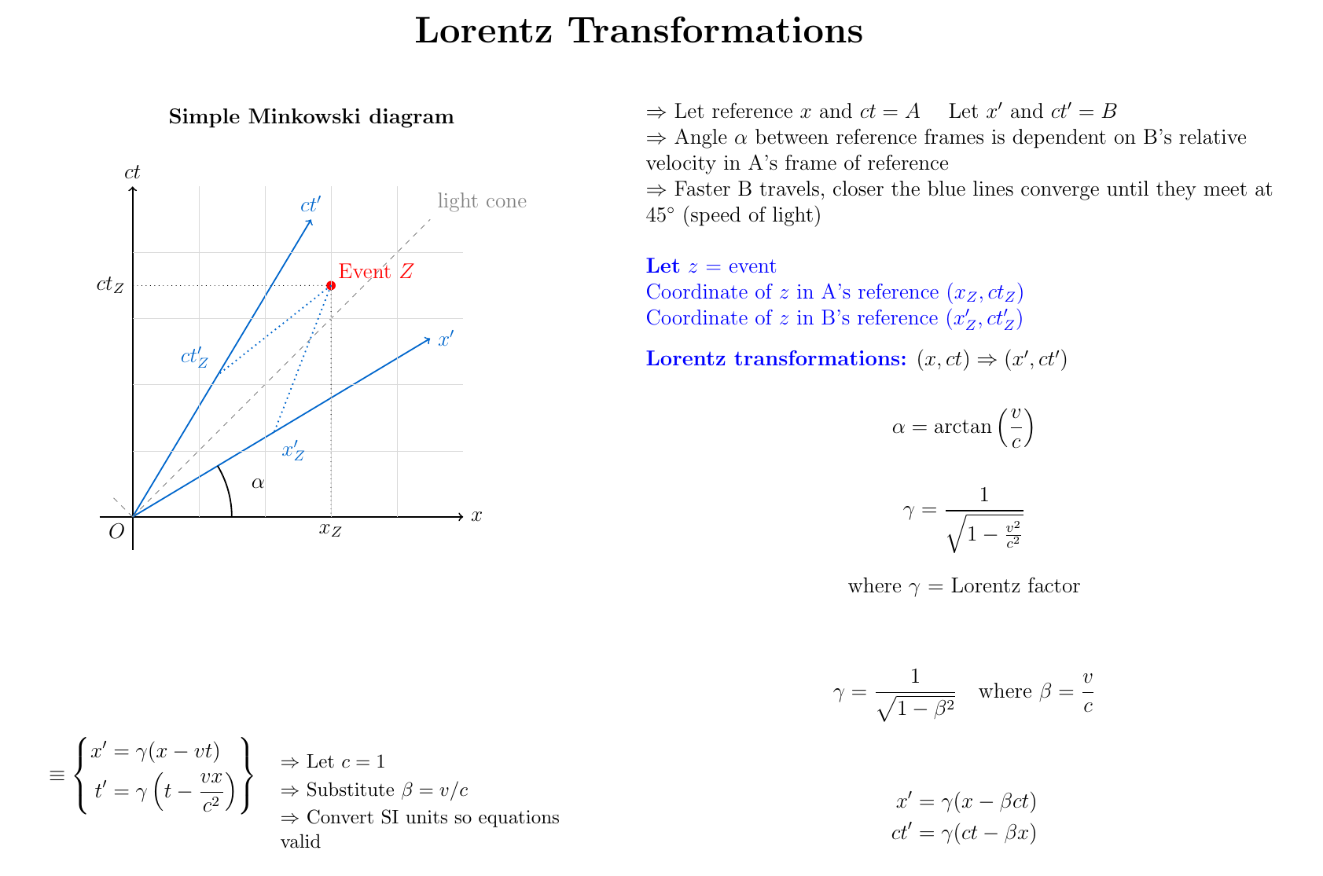
Figure 3 Generated in Latex: Capturing Lorentz Transformations on a Minkowski diagram
The diagram shows time plotted against a spatial reference with the vertical axis written as $ct$ so that time has the same units as distance and the geometry of the spacetime interval is represented correctly. The blue lines show the axes of B’s reference frame while the main axes show A’s frame, and the dotted line marks the light cone which sets the upper limit for how far B’s axes can rotate. This upper limit occurs when the rotation angle alpha reaches 45°. Using $ct$ allows space and time to be placed on a single geometric scale which reflects Einstein’s postulate that the speed of light is constant for all inertial observers. As a result, the coordinates x and $ct$ in A’s frame transform directly to $x^{'}$ and $ct^{'}$ in B’s frame in a way that captures how space and time adjust with relative velocity.
These transformations are essential for understanding how different observers measure time in high-velocity environments and are therefore fundamental in aerospace engineering. Satellites, spacecraft, and orbital systems routinely experience speeds where classical mechanics is no longer accurate, so corrections based on Lorentz transformations become necessary. Later in Chapter 5, these transformations will be explored in simplified form, and Chapter 6 will discuss how aerospace engineers use these equations to predict time dilation so internal clock systems can be adjusted beforehand.
An alternative and more intuitive representation uses linear transformations [5], which can be easily implemented directly into computer programs. This approach allows engineers to automate SR effects when modelling navigation systems, orbital manoeuvres, and synchronised time signals.

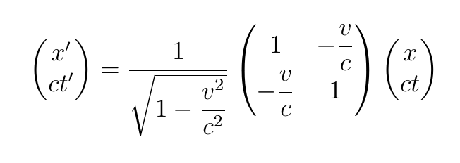
Figure 4 Generated in Latex: Capturing the Lorentz Transformation in Matrix form

3.4 Chapter Summary
In summary, the laws of physics are the same in all inertial frames, and the speed of light is constant for all observers regardless of their relative motion. These two postulates directly lead to the idea of simultaneity and the conclusion that time does not pass at the same rate for all observers. In the light clock thought experiment, a moving clock forces light to travel along a longer path, and because the speed of light cannot increase, the only possible outcome is that time itself must slowdown in the moving frame. Simultaneity therefore demonstrates that the universal speed limit causes events to appear differently depending on one’s frame of reference. This effect is quantified by the Lorentz transformations and becomes significant in aerospace engineering, where high velocities make relativistic corrections essential.

General Relativity (1915)

4.1 Curved Spacetime
In the previous chapter, I explored time dilation caused by relative motion using Einstein’s Special Relativity. I now shift the focus to the way gravity affects the passage of time, which can only be explained by Einstein’s theory of General Relativity. This theory redefined gravity by replacing Newton’s description of a force acting at a distance with the idea that mass and energy bend the geometry of spacetime. Massive objects such as planets or stars change the structure of the spacetime around them, and smaller objects move along the curved paths created by this distortion [7]. In this sense, an orbit is not the result of a pulling force but the natural path that an object follows in curved spacetime.
This idea can be visualised by imagining spacetime as a flexible sheet that deforms when a heavy object is placed on it. Although this picture is limited because it represents four-dimensional spacetime using a two-dimensional analogy, it helps build intuition for how mass alters the geometry of its surroundings. The image below illustrates how a planet creates curvature in spacetime and influences the motion of nearby objects [20].
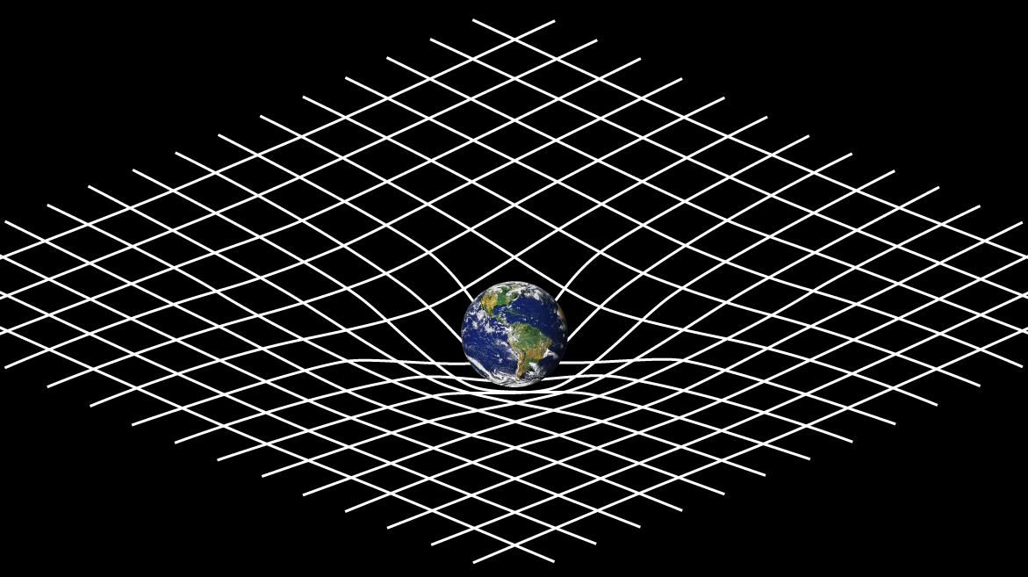
Figure 5 Capturing the distortion of Spacetime due to mass

4.2 The Equivalence Principle
A key insight that led Einstein to gravitational time dilation was the equivalence principle. This principle states that the effects of a gravitational field are locally indistinguishable from the effects of acceleration. A person inside a sealed room cannot determine whether the force they feel is caused by gravity or by the upward acceleration of the room itself. Since Special Relativity shows that acceleration affects the measurement of time, Einstein concluded that gravity must also influence the rate at which time passes [8].
This principle links gravity to time dilation by showing that a stronger gravitational field, which corresponds to a sharper curvature of spacetime, causes clocks to run more slowly. John Wheeler summarised this relationship with the statement that spacetime tells matter how to move and matter tells spacetime how to curve. This concept is essential in aerospace contexts where satellites and spacecraft operate in regions with different gravitational potentials and therefore experience measurable variations in their flow of time.

4.3 Time Dilation Near Massive Bodies
To describe how gravity shapes the behaviour of time, Einstein and Marcel Grossmann formulated the Einstein Field Equations, which relate the distribution of mass and energy to the curvature of spacetime. Although the full tensor structure of these equations is mathematically complex, their implications can be understood through specific solutions. One of the most important solutions is the Schwarzschild metric. As outlined by Ashby [17], this metric describes the geometry of spacetime outside a non-rotating, spherical mass. It is written as a complex differential equation which can be solved to give a static solution for time where the observer is at a fixed distance r from the centre of mass.
The component of the Schwarzschild metric relevant to gravitational time dilation is shown below.
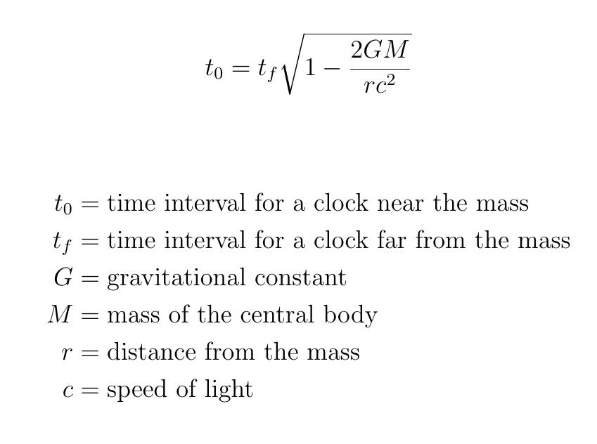
Figure 6 Generated in Latex, Capturing time dilation due to GR
As the radial distance r decreases, the expression inside the square root becomes smaller. This leads to a smaller value of the proper time interval $t_{0}$ compared to the coordinate time interval $t_{f}$ experienced further from the mass. Consequently, clocks positioned closer to a massive object tick more slowly than those located at a greater distance. This slowing of time becomes increasingly significant near extremely dense bodies and is observable even in the gravitational fields of planets such as Earth.

4.4 Chapter Summary
General Relativity offers a geometric framework for understanding how gravity shapes the passage of time. Rather than acting as a conventional force, gravity arises from the curvature of spacetime caused by mass and energy. Objects move along the natural trajectories defined by this curvature, and the strength of the gravitational field governs the rate at which time passes. Clocks positioned closer to massive bodies experience slower time, an effect that becomes increasingly pronounced near extremely dense objects and is measurable even in the gravitational field of Earth. Although subtle, this phenomenon is critical for modern aerospace systems, as satellites and spacecraft rely on highly precise time measurements. Accounting for gravitational time dilation is therefore essential to ensure the accuracy and reliability of navigation and communication technologies in space.

Challenges in Aerospace Systems

5.1 Introduction
Time dilation arises from two relativistic effects: relative motion between frames of reference, described by Special Relativity, and differences in gravitational potential, described by General Relativity. These phenomena pose significant challenges for aerospace engineers, as even minor discrepancies in the passage of time can compromise the accuracy of satellite navigation, orbital manoeuvres, and high-speed spacecraft operations.
In this chapter, we examine these challenges conceptually and mathematically, exploring how time dilation manifests in practical aerospace scenarios. For velocity-based calculations, we simplify the Lorentz transformation by setting $x^{'}=0$, as clocks remain stationary in their own frame. This allows focus on the standard velocity time dilation equation.
To maintain clarity, the following abbreviations for orbital regimes are used throughout the chapter [18]:
- LEO: Low Earth Orbit
- MEO: Medium Earth Orbit
- GEO: Geostationary Earth Orbit
- Periapsis: the closest point in an orbit to the body being orbited
- Apoapsis: the furthest point in an orbit from the body being orbited

5.2 Time Dilation in GPS Satellites
Global Positioning System (GPS) networks rely on satellites orbiting Earth at altitudes of approximately 20,200 km and speeds of around 14,000 km/h [18]. Each satellite carries highly precise atomic clocks that form the basis for accurate position calculations on Earth. However, due to relativistic effects, these satellite-based clocks tick at a different rate than clocks on the surface. This time discrepancy arises from two competing sources: Special Relativity and General Relativity.
According to Special Relativity, the high velocity of the satellite relative to an observer on Earth causes the satellite’s clock to tick more slowly. Consider a typical GPS satellite in medium Earth orbit (MEO).

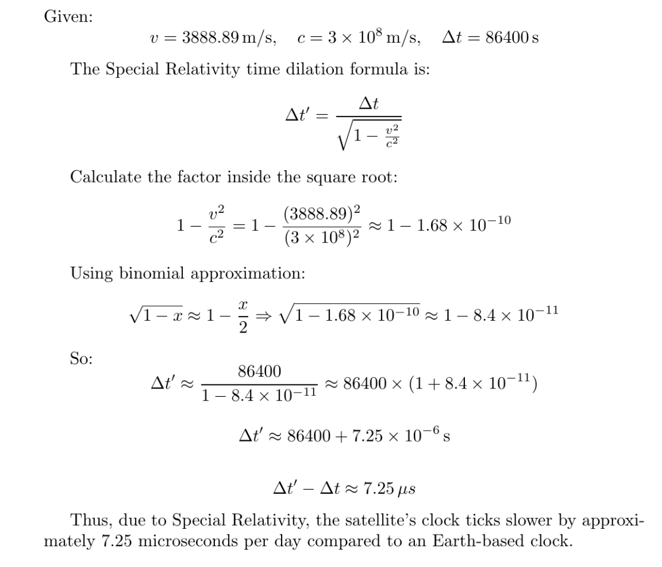
Figure 7 Generated in Latex, Capturing the magnitude of time dilation due to SR
The time dilation resulting from satellite velocity is shown here. Applying the velocity time dilation formula from chapter 3, the satellite clock is found to slow by approximately 7.25 microseconds per day. A binomial approximation is used since the value under the square root is extremely small, preventing computational errors or rounding issues.
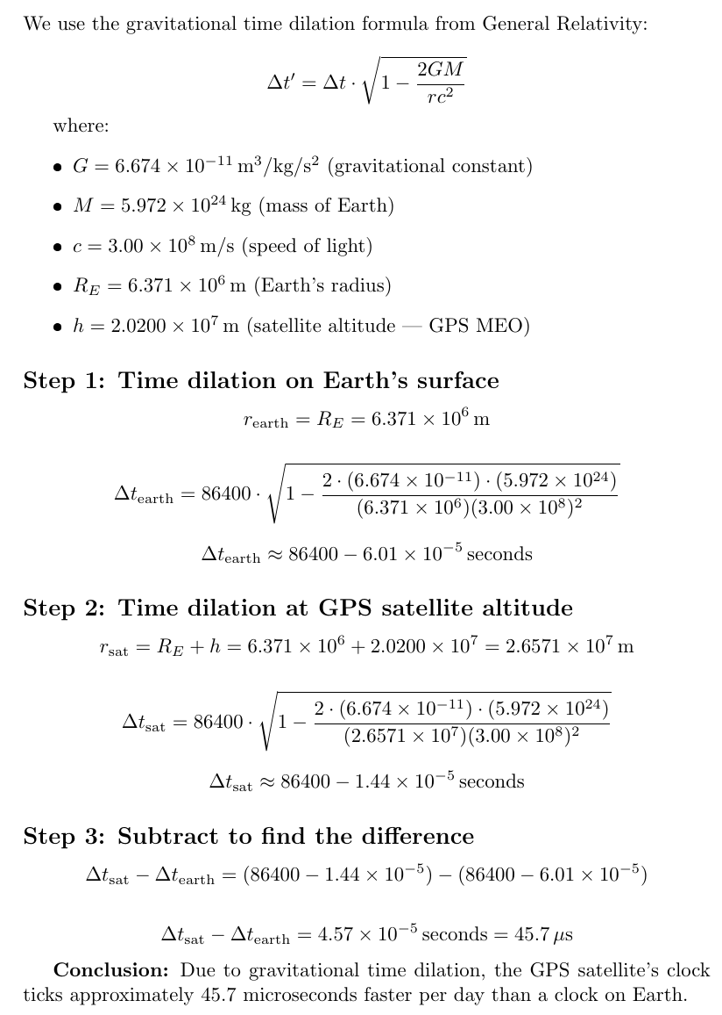
Figure 8 Generated in Latex, Capturing the magnitude of time dilation due to GR
The corresponding time discrepancy due to General Relativity is illustrated. Clocks in weaker gravitational fields run faster than those on the Earth’s surface, as the gravitational field strength at the satellite’s orbit is lower. To determine the net effect for an observer on Earth, the time dilation is calculated separately at the satellite’s orbital radius and at the Earth’s surface, and the difference between these values is taken.
By considering both Special and General Relativity, the overall magnitude of time dilation and the resulting positional error can be determined.
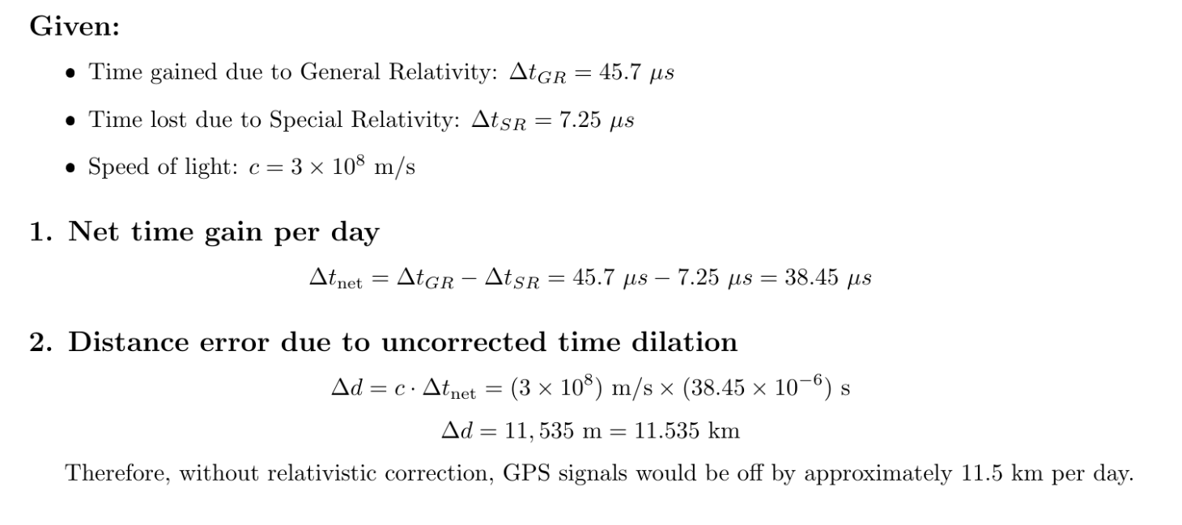
Figure 9 Generated in Latex, Capturing the overall magnitude of time dilation due to Sr and GR
As shown, a time discrepancy of just 38 microseconds can cause significant distortions in GPS signal accuracy, making relativistic corrections essential [11]. While the overall difference is small, uncorrected microsecond-level variations can lead to positional errors of up to 11 km, highlighting why relativistic corrections are essential in GPS systems. Chapter 6 will explore how engineers pre-adjust and synchronise these satellite clocks to mitigate the effects of time dilation.

5.3 Time dilation in orbital mechanics
Orbital mechanics concerns the study and application of motion in space, particularly the gravitational and centripetal forces governing orbital motion. Although Chapter {4} introduced gravity as a geometric effect under General Relativity, in this section we adopt the Newtonian model, where gravity is treated as a force. This approach remains accurate for calculating satellite trajectories and orbital transfers. However, when precise timing is critical, such as during satellite deployment or course corrections, relativistic effects must also be considered.
A key method used by aerospace engineers to transfer spacecraft between two circular orbits is the Hohmann transfer. This manoeuvre is preferred because it is the most fuel-efficient, requiring changes only to the magnitude of the spacecraft's velocity, not its direction, thereby minimising energy expenditure [13]. The Hohmann transfer uses an elliptical orbit that intersects both the initial and final circular orbits.
In this process, the spacecraft begins in a circular orbit of radius $r$and aims to reach a higher circular orbit of radius $r^{'}$. A burn is first performed to place the spacecraft into an elliptical transfer orbit, with periapsis at radius $r$and apoapsis at radius $r^{'}$. Upon reaching apoapsis, a second burn circularises the orbit, allowing entry into the target path.
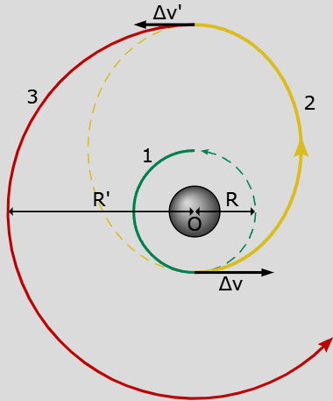
Figure 10
While Newtonian mechanics is sufficient to model the path and velocity changes, time dilation due to both gravitational and velocity-related effects must be factored in for high-precision missions. This is particularly important when synchronising clocks during orbital manoeuvres or coordinating with ground-based systems. The transfer orbit, indicated by curve 2 in Figure 10, is the critical segment of the manoeuvre and must be precisely timed to ensure efficiency. Therefore, understanding the magnitude of time dilation is essential.
Firstly, the governing equations for orbital mechanics are defined:
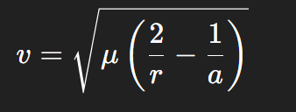
Figure 11 Vis-Viva equation

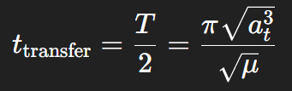
Figure 12 Transfer time equation
Now let’s consider a satellite undergoing a transfer orbit from LEO to GEO.
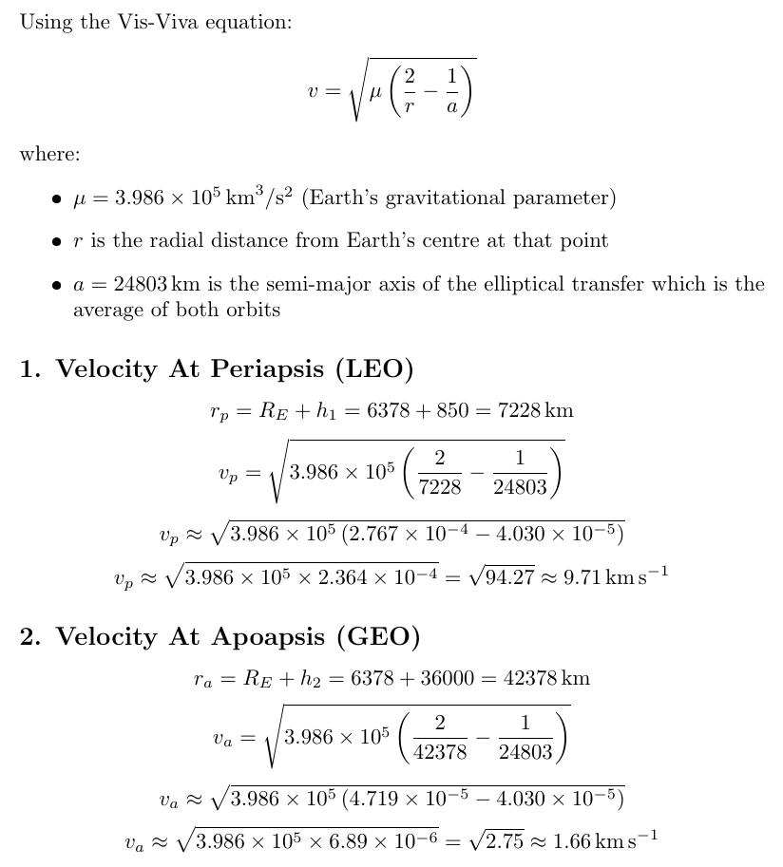
Figure 13 Generated in Latex

The transfer time is:
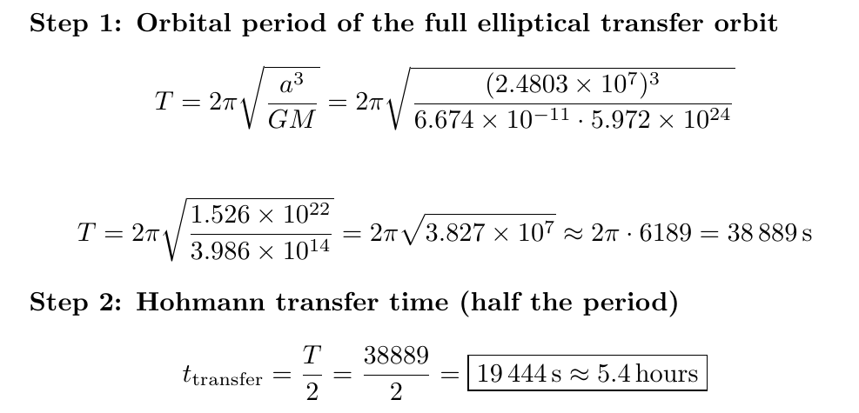
Figure 14 Generated in Latex
Since the satellite travels along an elliptical transfer orbit during the Hohmann manoeuvre, exact time dilation would require integrating relativistic effects over continuously changing velocity and radius. For clarity, we approximate the time dilation by evaluating general and special relativistic effects at two key points: periapsis and apoapsis. By assigning equal transfer times to each point, we obtain $t=2.7$hours, or 9720 s, at periapsis and apoapsis.
Now computing the time dilation effects at the periapsis and apoapsis points by considering SR and GR effects separately and comparing their magnitudes:
At Periapsis :
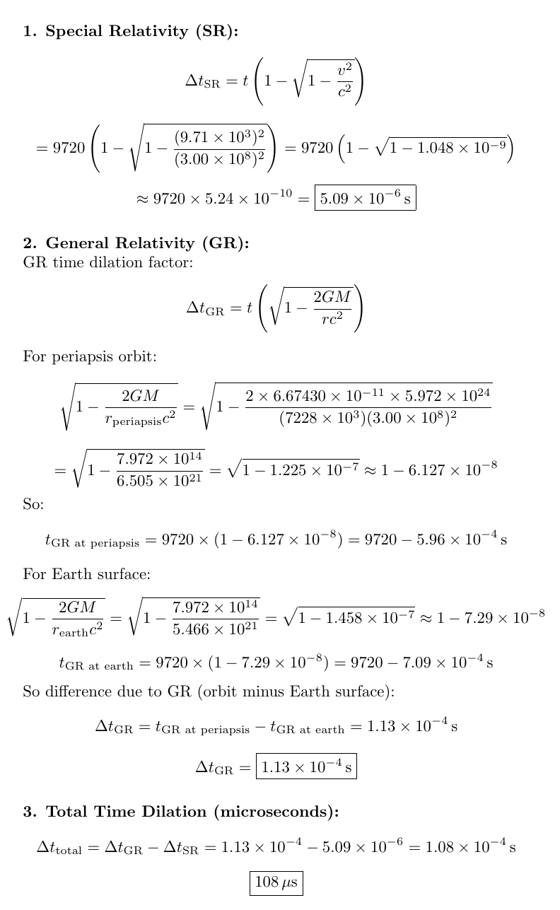
Figure 15 Generated in Latex, Capturing the magnitude of time dilation at the periapsis
At Apoapsis: 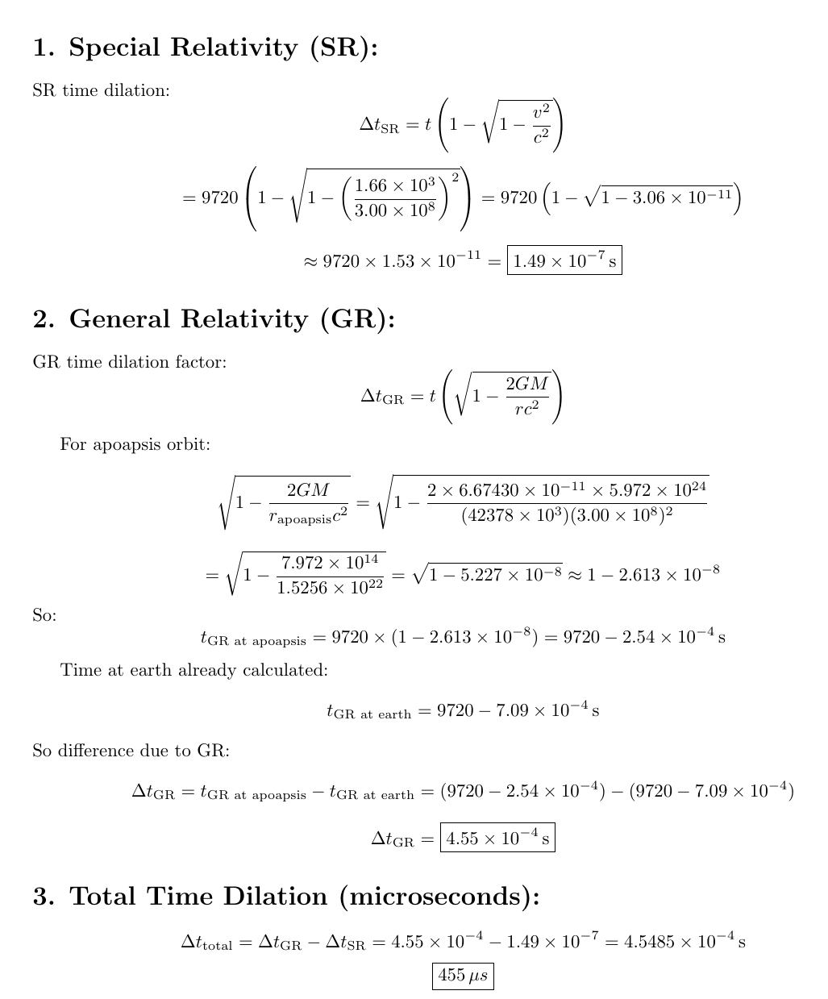
Figure 16 Generated in Latex, Capturing the magnitude of time dilation at the apoapsis
By comparing our calculated total time dilation values at the periapsis and apoapsis points, differences in gravitational potential dominate the effect. Time dilation at apoapsis is over four times greater than at periapsis, indicating that satellites in GEO, where satellites are travelling slower but in higher gravitational potentials, are most affected by relativistic effects. This will have higher implications for deorbit manoeuvres, where precise timing is critical for safe re-entry. Although the time discrepancies of 108 and 455 microseconds may appear negligible, their impact becomes clear when translated into spatial displacement. A spacecraft at periapsis experiencing 108 microseconds of time dilation and travelling at 9.71 km/s will drift approximately 1.05 m, while one at apoapsis with 455 microseconds of dilation at 1.66 km/s will drift by about 0.76 m.
These calculations assume typical satellite speeds. While an increase in rotational speed at apoapsis would lead to greater spatial displacements, this scenario is unlikely, as satellites at higher altitudes travel more slowly due to the reduced centripetal force required to maintain orbit. Consequently, satellites at periapsis, despite experiencing lower time dilation, can undergo greater spatial displacement due to the higher velocities needed to sustain orbit.
Although individual deviations are small, they can accumulate over multiple manoeuvres and be amplified by sensor drift or actuator lag. In worst case scenarios this accumulation could cause satellites to drift away from their designated orbital slots particularly for communication or weather satellites where precise positioning is essential. This shows that accounting for relativistic effects during orbital manoeuvres can become relevant in principle. However, the calculations confirm that although these effects are real, their magnitude remains far smaller than the operational tolerances of spacecraft. While an approximate peak drift of 1.05m is theoretically measurable, it is still much smaller than deviations caused by factors such as atmospheric drag which, over multiple manoeuvres, can become much more significant than time dilation. For example, source [23] depicts atmospheric drag during quiet solar periods to be about 13-29m per day and in extreme cases, differ by 65-142m during solar storm. This shows that atmospheric drag is at least 13 times more powerful than time dilation, and during solar storm, it is over 100 times more significant. This means that in the context of standard orbital manoeuvring, time dilation is mainly a secondary concern, unlike in GNSS systems where the cumulative nature can become mission critical.

5.4 Time Dilation Effects on Rockets Leaving Planetary Gravity
For space missions beyond Earth, rockets must achieve the planetary escape velocity to overcome a planet’s gravitational influence. For Earth, this velocity can be calculated using the equation: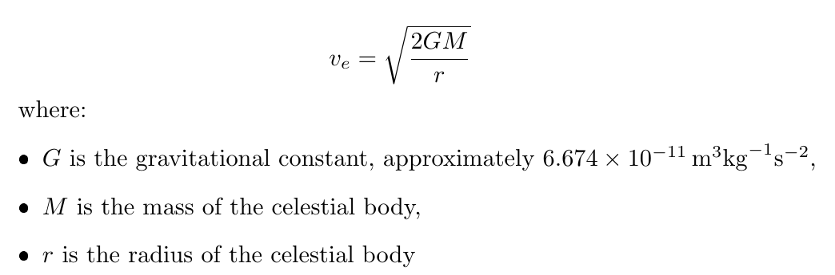
Figure 17 Generated in Latex, Capturing the Delta V equation
The resulting escape velocity for a rocket leaving Earth is approximately 11.18 km/s. This allows us to estimate the time dilation experienced by the rocket. Unlike the previous satellite scenarios, the rocket’s trajectory does not correspond to a fixed orbital radius; instead, it approaches a radius of infinity, where the gravitational potential effectively reaches zero. Consequently, the general relativity equation for the difference in time dilation between two gravitational potentials is applied: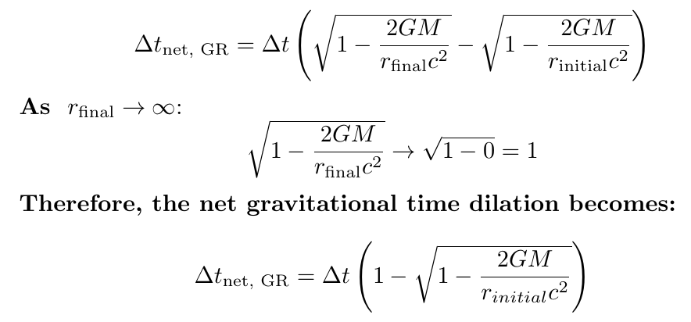
Figure 18 Generated in Latex
Using this framework, the magnitude of time dilation for a rocket travelling along a trajectory beyond Earth’s gravitational influence at escape velocity can be computed:
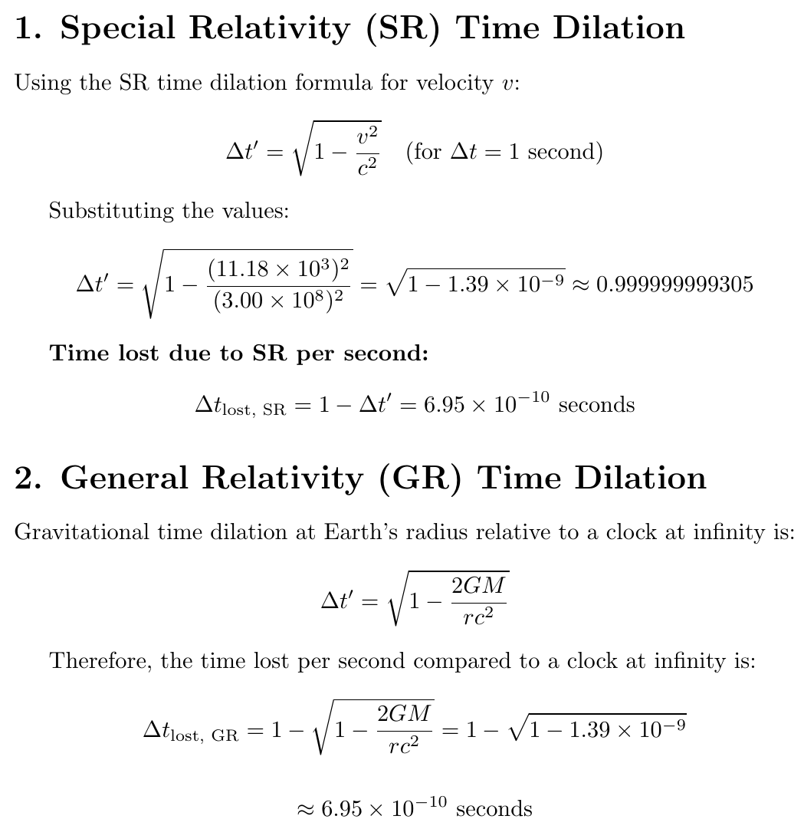
Figure 19 Generated in Latex
It’s also important to highlight that these calculations are approximations. The relationship between time dilation and a rocket’s trajectory through spacetime is non-linear and would require solving an integral over the spacetime path of the rocket to fully capture the combined relativistic effects. Here, however, we treat both forms of time dilation as additive and evaluate them independently at a single snapshot in the rocket's journey.
During ascent, the rocket accelerates under engine thrust, reaching escape velocity, after which its velocity decreases under gravitational deceleration once engine thrust ceases and the rocket coasts. Consequently, the contribution of Special Relativity to time dilation diminishes along the trajectory. Simultaneously, as the rocket gains altitude, the time dilation due to General Relativity relative to Earth’s surface increases, causing the onboard clock to tick progressively faster compared to clocks on Earth. This demonstrates that the relative influence of Special and General Relativity shifts continuously throughout the rocket’s journey.
In summary while Special and General Relativity effects may appear to cancel at the escape velocity from Earth’s surface this equality holds only under that specific condition. It represents a unique intersection point of two distinct relativistic effects velocity-based time dilation in Special Relativity and gravitational time dilation in General Relativity where their respective curves intersect at escape velocity. However, the underlying mechanisms and frames of reference remain fundamentally separate.
With that in mind although the calculations show clear relativistic effects the practical impact is less straightforward to quantify. Much of the available literature focuses on the physics rather than specific engineering tolerances so assessing operational significance requires reasonable assumptions about mission design and navigation accuracy. While the numerical results give a sense of scale the true influence of these effects depends on context system precision and how onboard software handles timing and positioning. Because detailed mission level data is rarely published some uncertainty remains when translating the theoretical values into real operational consequences. Taken together the analysis shows that relativistic effects along an escape trajectory are theoretically measurable but remain too small to influence guidance, navigation or mission design and are therefore not considered critical for conventional rocketry.

5.5 Limitations of Methods

The calculations in this dissertation utilize standard expressions from Special and General Relativity, with deliberate simplifications made to maintain a transparent analytical framework within the scope of A-level mathematics.
In the Hohmann transfer (5.3), relativistic effects were evaluated at periapsis and apoapsis rather than integrating continuously over the full trajectory. While a continuous path integral would provide absolute precision, the 'snapshot' method was chosen as a purposeful comparative tool. It allows for a clear demonstration of how extreme variations in altitude and velocity influence the magnitude of dilation, providing a 'range' of impact that is more illustrative for engineering evaluation than a single cumulative value.
Furthermore, in the escape velocity scenario in chapter 5.4, the model assumes a perfect vertical ascent. In practical aerospace engineering, rockets execute a 'gravity turn' where the velocity vector progressively tilts to achieve orbit. Consequently, my model likely overestimates the time spent in high-velocity regimes at lower altitudes where gravitational potential is strongest. However, since the derived dilation remained sub-microsecond and thus operationally non-critical, this simplification remains scientifically justified. It confirms that even under theoretical conditions, time dilation remains secondary to mechanical tolerances.
Lastly, satellite calculations assumed near-circular orbits, omitting non-gravitational perturbations such as atmospheric drag, solar radiation pressure, or Earth's non-spherical mass distribution (mascons). By isolating time dilation, this project creates a 'laboratory' view of the physics. While this excludes a total mission error probability, it provides a rigorous baseline for the theoretical maximum impact of relativity. This allowed us to focus on the dissertation’s underlying question without the results being obscured by external, unpredictable environmental variables.

5.6 Chapter Summary
In this chapter, we have explored in detail the various relativistic effects that aerospace engineers must consider when designing and operating spacecraft. We began by examining time dilation in orbital satellites, highlighting the competing influences of Special and General Relativity and their impact on GPS systems. We then analysed orbital manoeuvres, including Hohmann transfers, and demonstrated how time dilation varies at key points along a satellite’s trajectory, influencing both timing and positional accuracy. Finally, we extended the discussion to rockets escaping Earth’s gravitational field, considering how velocity and gravitational potential interact to produce continuously changing relativistic effects along the ascent trajectory.
Through these analyses, it becomes clear that even seemingly minor relativistic discrepancies, on the order of microseconds, can translate into significant spatial errors, affecting mission success and operational reliability. The chapter has emphasised the importance of understanding both the magnitude and the dynamic nature of these effects, providing a foundation for practical mitigation strategies.
The following chapter will build on this understanding, examining how engineers address these challenges in practice by implementing technologies and methods to correct and compensate for relativistic time dilation in aerospace systems.

Mitigation Strategies for Time Dilation

6.1 Introduction
The previous chapter demonstrated that relativistic effects are not theoretical curiosities but measurable influences that can significantly alter the performance of modern aerospace systems. Time dilation was shown to create substantial discrepancies in satellite clocks, to introduce subtle timing variations during orbital manoeuvres and to impose constraints on long-distance navigation. These calculations established that the consequences of ignoring relativistic physics range from kilometre-scale positioning errors in satellite navigation to smaller timing deviations that accumulate during high velocity spacecraft operations.
Chapter 6 now examines how aerospace engineers respond to these challenges in practice. It begins by establishing the role and operation of the atomic clock, which forms the foundation of all high-precision timing systems. It then analyses how engineers modify satellite clock behaviour to counteract the net relativistic drift produced by Special and General Relativity. Finally, it considers how timing precision is handled in contexts where mitigation is less direct, including spacecraft navigation and deep space missions, and evaluates the circumstances under which relativistic awareness becomes essential. Through these examples, the chapter shows that the treatment of time dilation is highly dependent on mission context and is shaped by the accuracy required, the environment in which the system operates, and the engineering constraints placed upon it.

6.2 The Atomic Clock
Before examining strategies for correcting relativistic effects, it is essential to establish a clear understanding of the atomic clock. An atomic clock is the most precise time-keeping device available, and its performance depends on locking a microwave signal to the exact resonance frequency of caesium atoms [12, 17]. The clock generates a microwave field and exposes a stream of caesium atoms to this radiation. When the oscillator frequency matches the atoms’ natural resonance frequency, their response exhibits a clear, measurable maximum. The control system continually adjusts the oscillator until this maximum is achieved, at which point the microwave output is stabilised at the caesium resonance frequency.
Once stabilised, the clock measures time by counting the oscillations of this microwave signal. One second is defined as the duration required for exactly 9,192,631,770 oscillations of the calibrated field [12]. Because this definition is tied to a fundamental physical constant, the resulting precision is extraordinary, with modern caesium clocks drifting by only one second every 158 million years. This negligible internal uncertainty means the clock itself does not require correction during spaceflight. Its stability is also why atomic clocks form the basis of national time standards on Earth and are essential onboard satellites, where navigation and synchronisation depend on highly reliable timing signals.
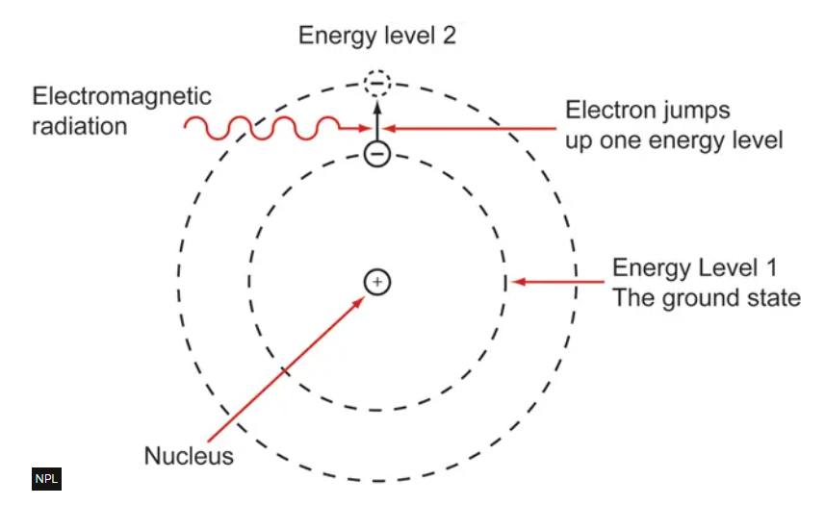
Figure 20 Capturing an Electron transitioning to a higher energy level [22]

The diagram in Figure 20 shows electrons transitioning between two energy states in a caesium atom. These transitions occur when the microwave oscillator in the atomic clock is tuned precisely to the resonance frequency of caesium. The electron movement is not used directly to measure time but serves as a reference to calibrate the microwave oscillator. When the oscillator frequency causes the maximum number of transitions, it is locked to the exact resonance frequency, producing a stable and reproducible microwave signal. Time is then measured by counting the oscillations of this stabilised signal, with one second defined as the duration of 9,192,631,770 oscillations [12]. The electron transitions therefore provide the mechanism by which the oscillator is stabilised at the resonance frequency of caesium, while the microwave oscillations themselves define the passage of time. This approach gives atomic clocks their extraordinary accuracy, with a drift of only one second every 158 million years, making them indispensable for both terrestrial time standards and satellite navigation systems.

6.3 Engineering Corrections Applied to Satellite Clocks
Although caesium atomic clocks provide an exceptionally stable definition of one second, engineers cannot rely on their raw output when placing them in orbit. Once a clock leaves Earth, it experiences two competing relativistic effects. Special Relativity causes the satellite clock to run slow due to its orbital velocity, while General Relativity causes it to run fast because it experiences weaker gravity than clocks on Earth. Combined, these effects lead to a net gain of approximately 38 microseconds per day as calculated in Chapter 5. This is vastly larger than the intrinsic drift of the clock itself, which is approximately 1 second every 158 million years. If left uncorrected, these relativistic shifts would accumulate rapidly and destabilise all satellite navigation systems.
To prevent this, engineers pre-adjust the oscillator inside each satellite clock on Earth. The clock is deliberately launched running slow so that in orbit, the relativistic shifts align it with ground-based time standards. In the GPS, the pre-launch frequency is set to 10.22999999543 MHz [14, 17]. Once in orbit, a user at sea level observes 10.23 MHz, eliminating the need for correction for this constant offset.
A secondary periodic effect arises from the slight eccentricity of the satellite orbit. As the satellite moves from perigee to apogee, changes in its speed and gravitational potential cause the clock to run slower or faster. At periapsis, higher velocity and lower gravitational potential slow the clock. At apoapsis, lower velocity and higher potential speeds it up. This effect is corrected using a periodic adjustment based on the satellite’s eccentric anomaly.
By combining the intrinsic stability of the caesium resonance with these relativistic pre-adjustments, satellite clocks remain synchronised with clocks on Earth. This allows GPS to achieve nanosecond-level timing accuracy, meaning that even a few nanoseconds of error would only cause millimetre-level positional inaccuracies, far smaller than the 11 km drift calculated in chapter 5 when relativistic effects were ignored.

6.4 Deep Space Atomic Clock (DSAC)
Deep space missions require high precision timing because spacecraft operate far beyond the range where continuous two-way communication with Earth is practical. The Deep Space Atomic Clock DSAC developed by NASA’s Jet Propulsion Laboratory is designed to provide this level of precision by maintaining an exceptionally stable onboard time standard. DSAC is a mercury ion atomic clock engineered to deliver nanosecond-level stability while remaining small enough and efficient enough to be carried on a spacecraft [15].
Although public technical documents focus primarily on timing stability and do not explicitly describe relativistic correction algorithms, the operational context of DSAC makes relativistic awareness unavoidable. A deep space probe encounters large variations in gravitational potential and may reach velocities far higher than those of Earth orbiting satellites. These changes cause measurable relativistic drift if left uncorrected. Because DSAC is intended for one-way autonomous navigation without continuous reliance on Earth-based timing signals, its internal system must maintain consistency across these varying relativistic environments [16]. The extreme stability demonstrated in flight tests, therefore, implies that DSAC either incorporates relativistic corrections directly or is designed so that any relativistic drift remains below the noise threshold of its oscillator.
This makes DSAC a strong example of how precise onboard timekeeping becomes essential as missions move further from Earth, where relativistic effects accumulate over long distances and long durations.

6.5 Chapter Summary
Chapter 6 has explored how aerospace engineers account for time dilation across different aerospace contexts, emphasising both the theoretical principles and their practical applications. In satellite systems, relativistic effects are highly significant; the combined influence of Special and General Relativity on GPS satellites leads to a net time gain of approximately 38 microseconds per day, corresponding to positional errors of up to 11 km if uncorrected. This scale of drift clearly demonstrates why satellite clock pre-adjustments are crucial, and why the precision of caesium atomic clocks, coupled with relativistic pre-launch corrections, is central to high-accuracy navigation. Nanosecond-level timing ensures that even minor residual errors translate only to millimetre-scale positional discrepancies, highlighting the necessity of these mitigation strategies in orbit.
However, beyond satellites, the practical application of time-dilation mitigation becomes less straightforward. For onboard rockets and spacecraft conducting orbital manoeuvres or Hohmann transfers, explicit strategies for counteracting relativistic drift are difficult to identify in the literature. Calculations confirm that time dilation exists in these scenarios; however, the resulting shifts are minimal relative to other operational tolerances and the multitude of engineering concerns that dominate mission design. Consequently, while relativistic effects are theoretically present, their direct mitigation is generally considered a secondary concern, managed almost entirely through mission planning, guidance algorithms, and software-based predictions rather than hardware adjustments.
In contrast, deep-space missions demonstrate that when mission precision is crucial, engineers do embed awareness of time dilation into system design. The Deep Space Atomic Clock (DSAC) provides a clear example: although public documentation does not explicitly confirm relativistic corrections, its extreme stability and purpose in one-way autonomous navigation imply that it mitigates timing errors arising from spacecraft velocity and varying gravitational potentials. DSAC ensures accurate trajectory control, manoeuvre execution, and scientific measurements even when Earth-based communication is limited, illustrating the critical role of precise timekeeping in enabling deep-space exploration.
Overall, Chapter 6 shows that the importance of relativistic corrections is context dependent. For Earth-orbiting satellites, mitigation is essential, directly influencing operational accuracy. For onboard rockets and typical spacecraft manoeuvres, the effects of time dilation exist but are relatively minor, and engineering solutions rely primarily on predictive modelling rather than active clock adjustments. Deep-space atomic clocks, however, highlight how relativistic awareness becomes crucial when extreme autonomy and precision are required, highlighting the continued relevance of Einstein’s theories in modern aerospace engineering.

Conclusion
This dissertation has examined both Special and General Relativity and shown how time dilation arises directly from the invariance of the speed of light and the curvature of spacetime. Velocity-based and gravitational time dilation were presented through the relevant mathematical formulations, including a derivation of the Special Relativity time dilation equation. The General Relativity expression was not derived from first principles because it requires Riemannian geometry which is beyond the scope of this project, but its physical meaning and engineering relevance were explained.
The analysis evaluated three aerospace contexts in which relativistic effects could influence system performance: GPS satellites, an orbital manoeuvre, and a rocket at escape velocity. Quantitative calculations showed that time dilation is highly significant for satellites, where microsecond-scale deviations accumulate into kilometre-scale positioning errors if left uncorrected. In contrast, the effects on rockets and typical orbital manoeuvres were shown to be extremely small, far below the thresholds that would affect guidance or mission planning.
Based on the quantitative data produced in this investigation, I have determined the criticality of time dilation is not a binary constant but exists on a scale of engineering priority. I categorised this scale as follows:
- Mission critical: In GPS/GNSS, time dilation is a primary design requirement. The calculated 38 microseconds of daily drift would lead to 11km positioning errors that would render the system useless.
- Technically Relevant: In deep-space navigation (DSAC), timing is a limiting factor in autonomy. While the drift doesn’t destroy the craft, it dictates the limits of how far a probe can navigate without Earth-based interventions.
- Secondary Concern: In standard orbital manoeuvres and rocketry, the 1.05m relativistic drift is effectively "noise". It is subsumed by mechanical tolerances and environmental forces like atmospheric drag, which was established in 5.3, can become over 100 times more significant during solar activity.
In direct response to the research question, time dilation is a critical factor only in aerospace systems where mission performance relies on precise, long-duration timing. For most conventional applications, relativistic effects are present but so small that they exert no meaningful influence on engineering decisions. Therefore, while from a purely physics perspective time dilation is always present and critical for a perfect model, from an engineering perspective, it is only critical if it exceeds the operational tolerances of the hardware. This investigation demonstrates that for propulsion-based systems, aerospace is currently in a 'pre-relativistic' engineering era, whereas for signal-based systems, it is already in a relativistic one.

Mathematical Derivations

7.1 The Lorentz factor

[19, 20, 21]
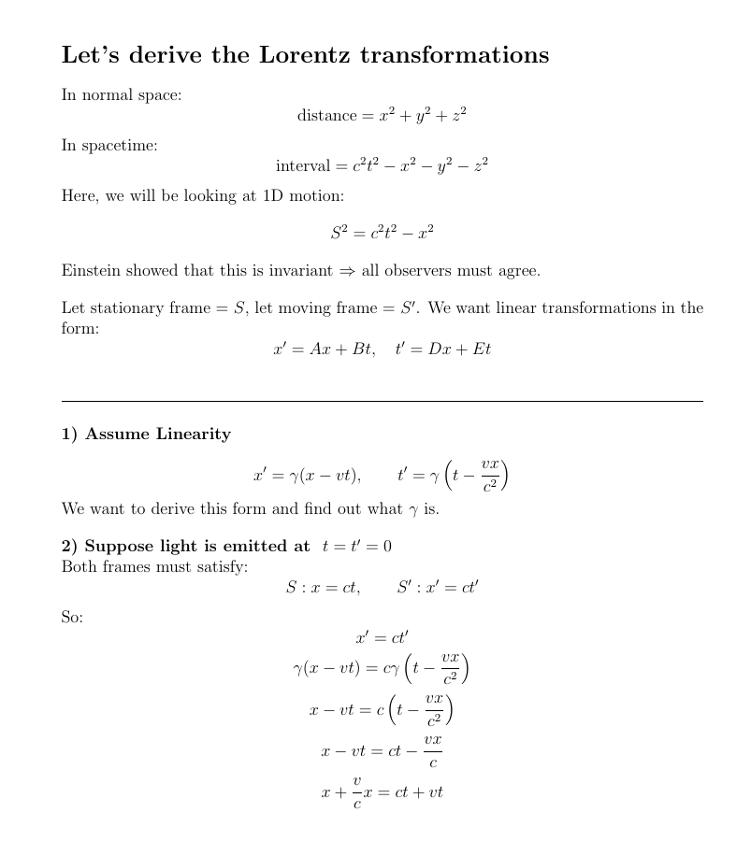
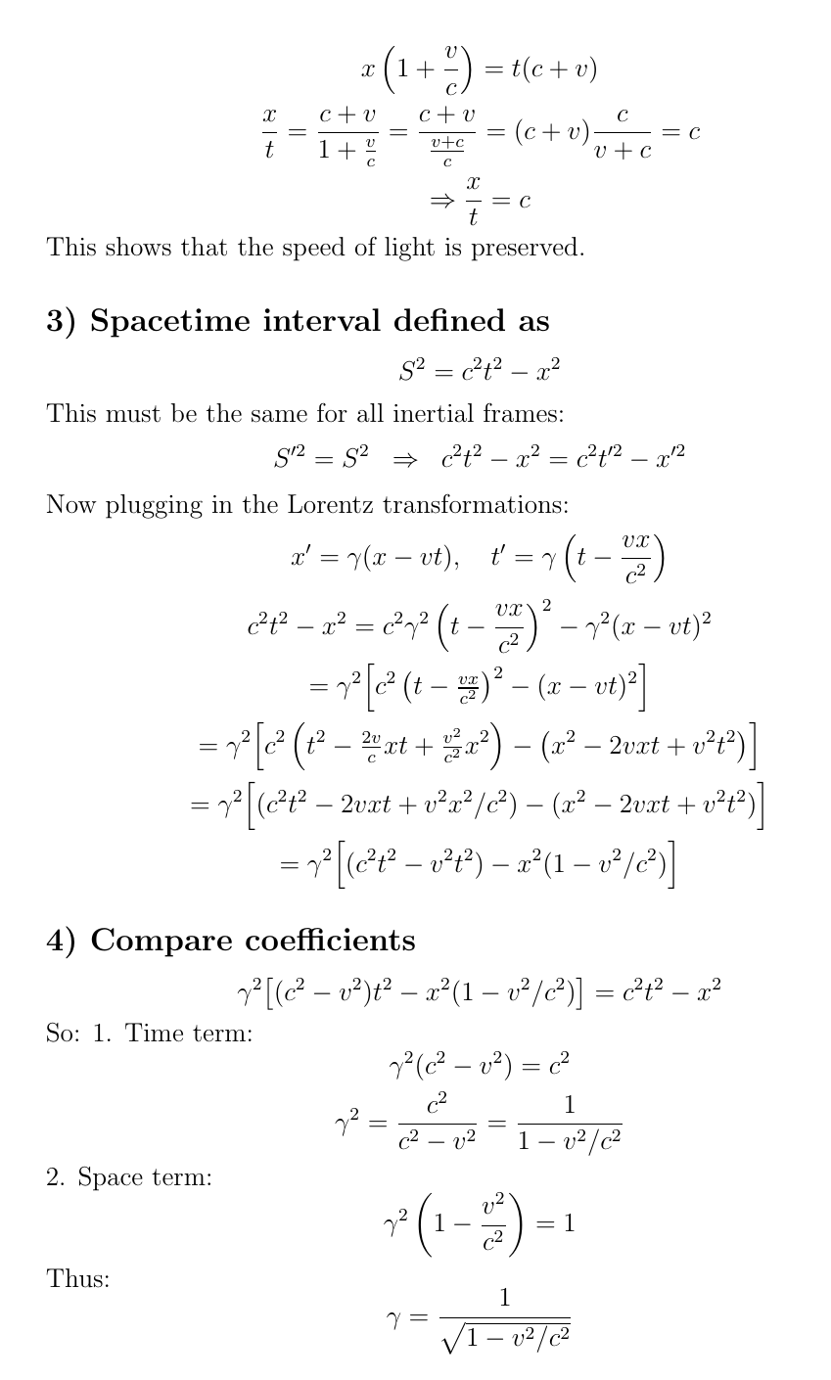
Figure 21 Generated in Latex

7.2 Time Dilation due to Special Relativity

[4, 22]
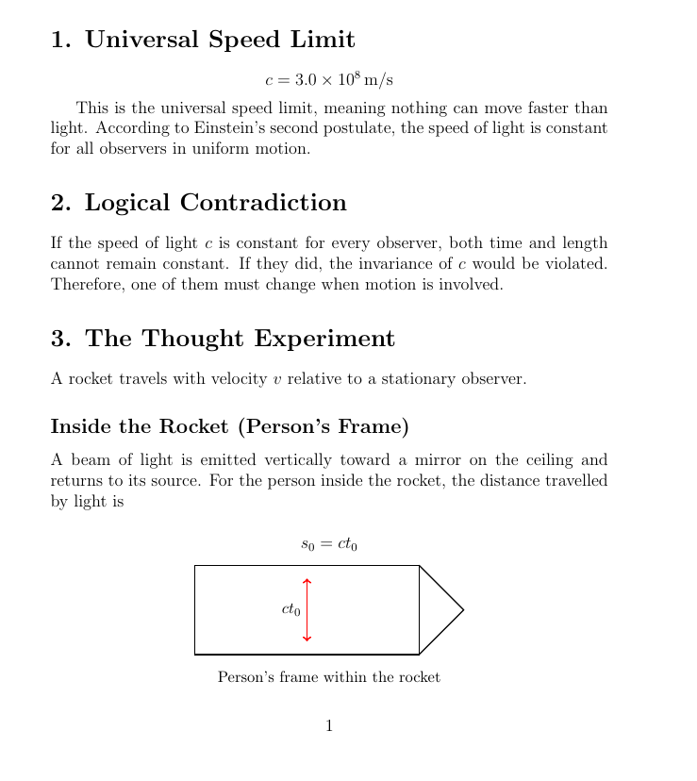
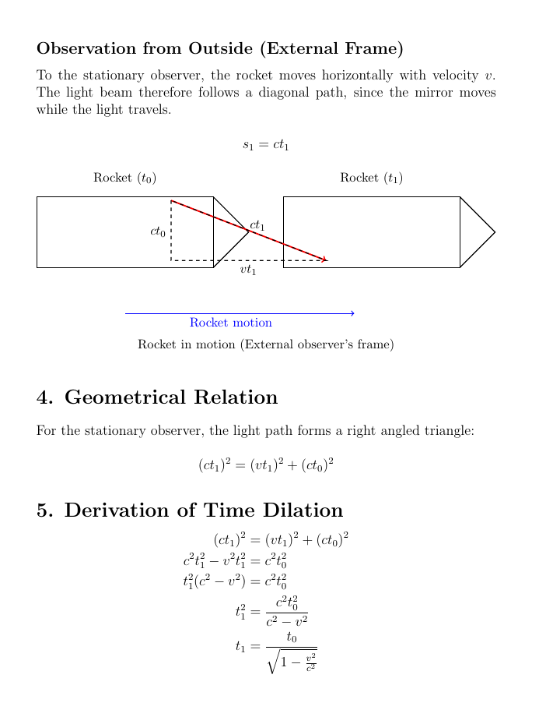
Figure 22 Generated in Latex

Here $t_{0}$ represents the time measured by the person inside the rocket, and $t_{1}$ represents the time measured by the stationary observer outside the rocket. Since $v>0$, the denominator is smaller than one, meaning $t_{1}>t_{0}$. Therefore, time passes more slowly for the moving observer. This time dilation arises from the geometric structure of spacetime rather than any physical slowing of clocks. Both observers agree on the value of $c$, but differ in their measurements of time, demonstrating that time is not absolute but relative and depends on motion.

References
- [1] Newton, I. (1999). The Principia: Mathematical Principles of Natural Philosophy. Translated by I.B. Cohen and A. Whitman. Berkeley: University of California Press. [online PDF] Available at: https://ia802907.us.archive.org/21/items/NewtonPrincipia_201701/The%20Principia%20Mathematical%20Principles%20of%20Natural%20Philosophy%20Isaac%20Newton.pdf.
- [2] Malleshappa, K. (2014). Time Dilation. International Journal of Scientific and Research Publications, [online] 4(9). Available at: https://www.ijsrp.org/research-paper-0914/ijsrp-p3334.pdf.
- [3] Einstein, A. (1905). ON THE ELECTRODYNAMICS OF MOVING BODIES. [online] Available at: https://www.fourmilab.ch/etexts/einstein/specrel/specrel.pdf.
- [4] Cox, B. (2015). Is Time Travel Possible? | The Science of Doctor Who. BBC YouTube. Available at: https://www.youtube.com/watch?v=-O8lBIcHre0.
- [5] Yakovenko, V. (2004). Derivation of the Lorentz Transformation Lecture Note. [online] Available at: https://physics.umd.edu/~yakovenk/teaching/Lorentz.pdf.
- [6] Encyclopaedia Britannica (2019). Michelson-Morley Experiment | Physics. Available at: www.britannica.com/science/Michelson-Morley-experiment.
- [7] SASF2023 (n.d.). What is Gravity? Explanation with space fabric. YouTube. Available at: https://www.youtube.com/shorts/iAtBRc4Nv0c.
- [8] Einstein, A. (1915). Relativity: The Special and General Theory. [online] Available at: https://www.gutenberg.org/cache/epub/5001/pg5001-images.html#pt2.
- [9] Eiley, S. (2022). Time Dilation. [online] STEM Fellowship. Available at: https://stemfellowship.org/time-dilation/.
- [10] Misra, P. (2023). Inside the box: GPS and relativity. GPS World. Available at: https://www.gpsworld.com/inside-the-box-gps-and-relativity/.
- [11] NASA (2020). Einstein’s Theory of Relativity, Critical For GPS. [online] Available at: https://www.nasa.gov/image-article/einsteins-theory-of-relativity-critical-gps-seen-distant-stars/.
- [12] NIST (2024). Beams of Atoms: The First Atomic Clocks. [online] Available at: https://www.nist.gov/atomic-clocks/beams-atoms-first-atomic-clocks.
- [13] Weber, B. (n.d.). Hohmann Transfer — Orbital Mechanics & Astrodynamics. Available at: https://orbital-mechanics.space/orbital-maneuvers/hohmann-transfer.html.
- [14] Kaplan, E. D. and Hegarty, C. J. (2006). Understanding GPS Principles and Applications. Second Edition. [online PDF] Available at: https://nguyenduyliemgis.wordpress.com/wp-content/uploads/2014/09/understanding-gps-principles-and-applications-2006.pdf.
- [15] NASA (2019). NASA Navigation Tech Shows Timing Really Is Everything. [online] Available at: https://www.nasa.gov/missions/tech-demonstration/nasa-navigation-tech-shows-timing-really-is-everything/.
- [16] Mohon, L. (2015). Deep Space Atomic Clock (DSAC) Overview. NASA. Available at: https://www.nasa.gov/directorates/somd/space-communications-navigation-program/deep-space-atomic-clock-dsac-overview/.
- [17] Ashby, N. (2003). Relativity in the Global Positioning System. Living Reviews in Relativity, vol. 6, no. 1. Available at: https://doi.org/10.12942/lrr-2003-1.
- [18] European Space Agency (2020). Types of Orbits. [online] Available at: https://www.esa.int/Enabling_Support/Space_Transportation/Types_of_orbits.
- [19] Khan Academy (2016). Lorentz Transformation Derivation Part 1. YouTube. Available at: www.youtube.com/watch?v=_qiFIMviIeM.
- [20] Khan Academy (2016). Deriving Lorentz Transformation Part 2. YouTube. Available at: www.youtube.com/watch?v=Lm_Yn_MZU6k.
- [21] Khan Academy (2016). Lorentz Transformation Derivation Part 3. YouTube. Available at: www.youtube.com/watch?v=xb8nBY4MDC8.
- [22] Physics High (2018). Time Dilation Formula Derivation (Special Relativity). YouTube. Available at: https://www.youtube.com/watch?v=1wmuGV2GIIM.
- [23] NOAA Space Weather Prediction Center (n.d.). Satellite Drag. [online] Available at: https://www.swpc.noaa.gov/impacts/satellite-drag

Bibliography
- Arvin Ash (2020). General Relativity Explained simply & visually. YouTube. Available at: https://www.youtube.com/watch?v=tzQC3uYL67U. (Used to help further understand General Relativity; an important resource for my initial understanding of time dilation).
- B, Jake. (2021). LaTeX for Students – a Simple QuickStart Guide. YouTube. Available at: https://www.youtube.com/watch?v=lgiCpA4zzGU. (Consulted for the technical formatting of the project).
- BBC News (2014). Caesium: A Brief History of Timekeeping. Available at: www.bbc.co.uk/news/magazine-29476893. (Used to understand the origins of the atomic clock).
- European Space Agency (2020). Types of Orbits. ESA. Available at: www.esa.int/Enabling_Support/Space_Transportation/Types_of_orbits. (Used to understand different Earth orbits).
- J. Ling, S., Sanny, J. and Moebs, W. (2016). 5.6: The Lorentz Transformation. Physics Libre Texts. Available at: https://phys.libretexts.org/Bookshelves/University_Physics/. (Exploration of Lorentz transformations as a correction to Galilean transformations).
- Khan Academy (2016). Evaluating a Lorentz Transformation. YouTube. Available at: www.youtube.com/watch?v=G-aTU0RXJww.
- Khan Academy (2016). Introduction to the Lorentz Transformation. YouTube. Available at: www.youtube.com/watch?v=HIQ5hnm61LQ. (Helped me further understand Lorentz transformations).
- Mattson, B. (2015). 100 Years of General Relativity. NASA Blueshift. Available at: asd.gsfc.nasa.gov/blueshift/index.php/2015/11/25/100-years-of-general-relativity/.
- PBS Space Time (2021). How Does Gravity Warp the Flow of Time? YouTube. Available at: https://www.youtube.com/watch?v=GKD1vDAPkFQ. (Helped to understand all aspects of time dilation).
- Roussel, A. (2021). Visualizing Time Dilation. YouTube. Available at: www.youtube.com/watch?v=5qQheJn-FHc. (Quick watch which helped me further graph time dilation).
- Septentrio (n.d.). Insight Article: GNSS Corrections Demystified. Available at: www.septentrio.com/en/learn-more/insights/gnss-corrections-demystified.
- University of Cambridge (n.d.). 7. Special Relativity. (Interesting read which formed the basis of my EPQ).
- Weinstein, G. (2023). A comprehensive survey of Schwarzschild’s original papers. Pitt.edu. Available at: https://philsci-archive.pitt.edu/22822/. (Incredibly difficult paper; invaluable for complete exposure to the mathematical backings)

